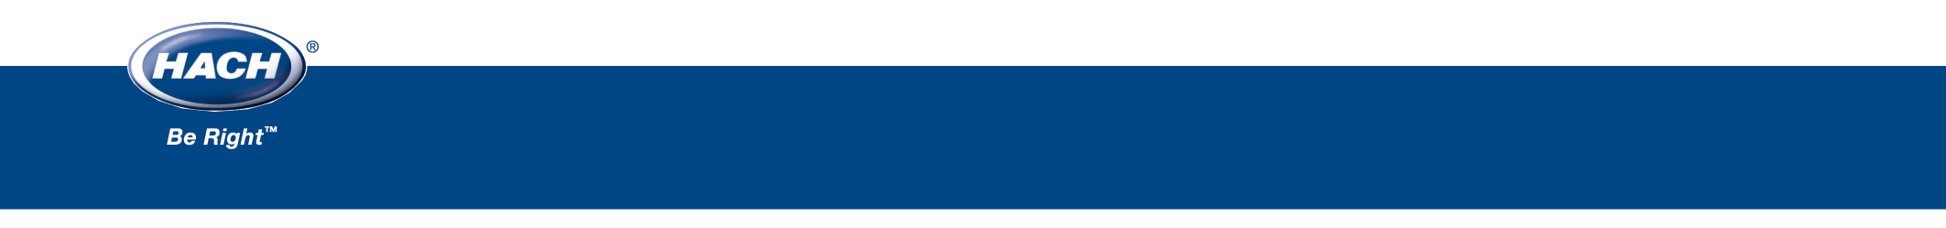
Hach Water Information Management SolutionTM (WIMSTM)
Case Study
Challenge:
The Metropolitan St. Louis Sewer District (MSD) is a public agency and the only special district in Missouri created under a provision of the State Constitution. MSD's responsibilities include the interception, collection and treatment of wastewater, as well as stormwater management. The District's current boundaries cover 525 square miles and encompass all of the City of St. Louis and approximately 80% of St. Louis County.
MSD serves a population of approximately 1.4 million and has approximately 519,000 single-family residential, multi-family residential and commercial/industrial accounts. Of these accounts, approximately 87,000 are for stormwater service only.
MSD currently operates seven (7) wastewater treatment facilities, treating a combined average of 330 million gallons of sewage per day. The District is responsible for operating and maintaining 9,649 miles of sewers.
MSD desired to replace their manual entry system for managing the complicated and disconnected operations data with an automated and integrated system to collect data from all of the wastewater treatment plants, the associated SCADA and control systems, and their central Laboratory Information Management System.
Solution:
Initially contemplating paying for custom development by one of the SCADA providers or building their own operations system, MSD discussed development with several consultants before finally understanding that not only would building their own product, or managing a custom SCADA solution, be an overwhelming task, but it would also be time prohibitive. They needed an automated system now and without the burden of long-term maintenance of software code.
Assessing the products in the marketplace, MSD started an extensive procurement process to select the product most suited to fit their needs. After numerous product demonstrations, the Hach Water Information Management Solution (Hach WIMSTM), formerly OPS SQL, was the unanimous decision. Key to its selection was its substantial reporting capabilities and its ability to interface with multiple systems.
Benefits:
Consistently utilizing the product since its selection, MSD continues to be happy with their choice. The system is currently used by all treatment plant managers and produces all required federal and state regulatory reports.
In demonstration of their satisfaction with the OPS Systems support, MSD specifically notes their timeliness to address issues and the ability to talk directly with an individual instead of an automated service.

Hach WIMSTM
Contact Information
HACH COMPANY
P.O. Box 389
Loveland, Colorado 80539-0389
U.S.A.
Telephone: 1-800-677-0067
E-mail: iimsales@hach.com
www.hach.com/im

Following selection, MSD was impressed with the ease of the Hach WIMS implementation. The system implementation included full product configuration, end user training, acceptance testing, and system roll-out.

